**EDUNET FOUNDATION - Class Exercise Notebook**

**LAB 2 – Chatbot Integration with Telegram**

Click on the connect option:

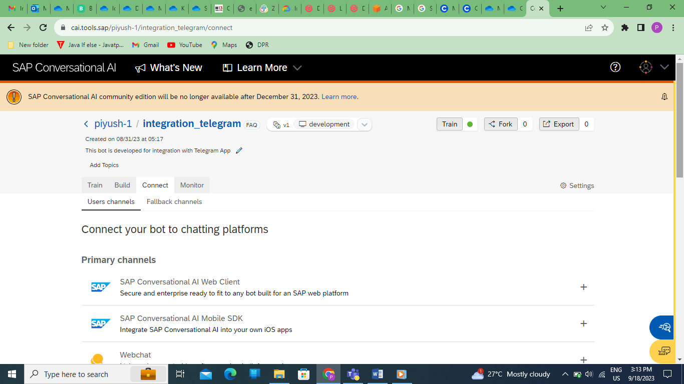

Now you will get the list of different third-party channels

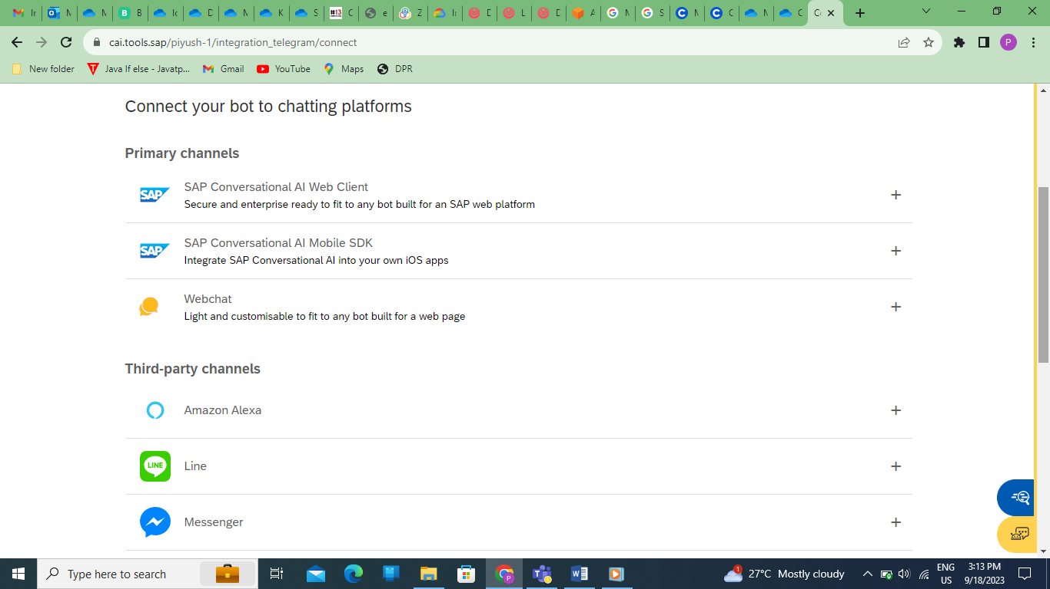

Click on the + symbol option of Telegram

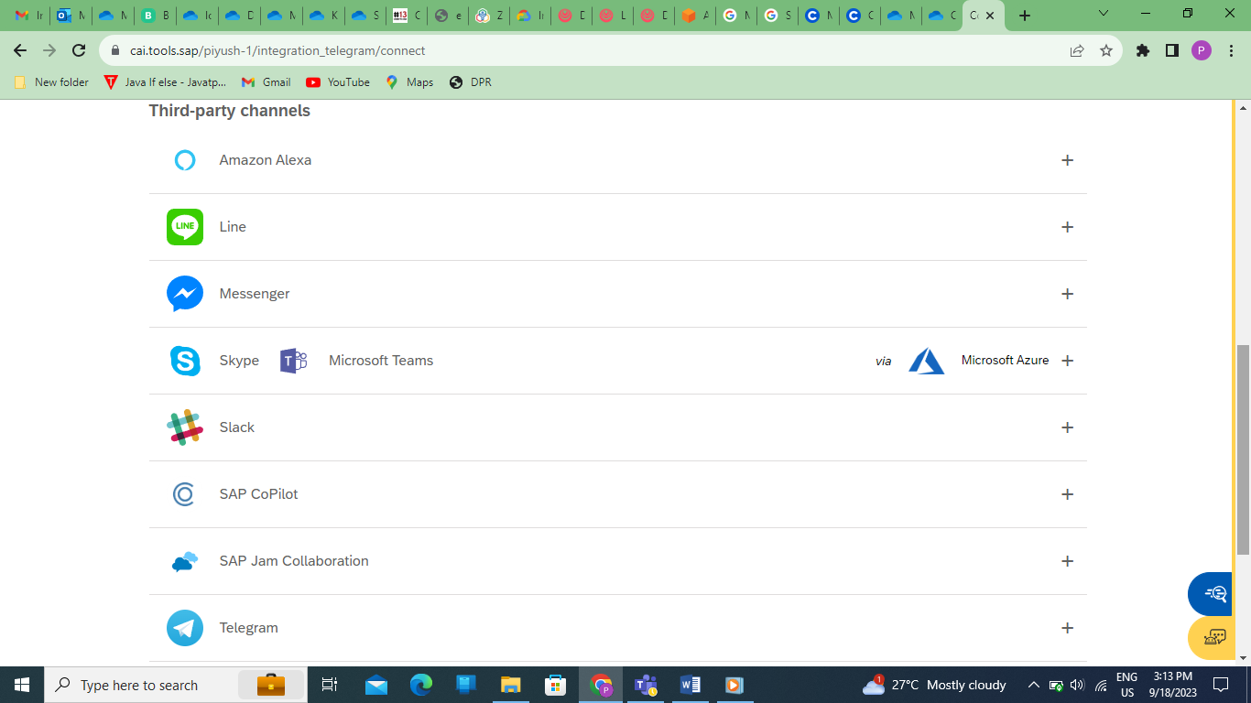

Now step by step follow the instruction mentioned below

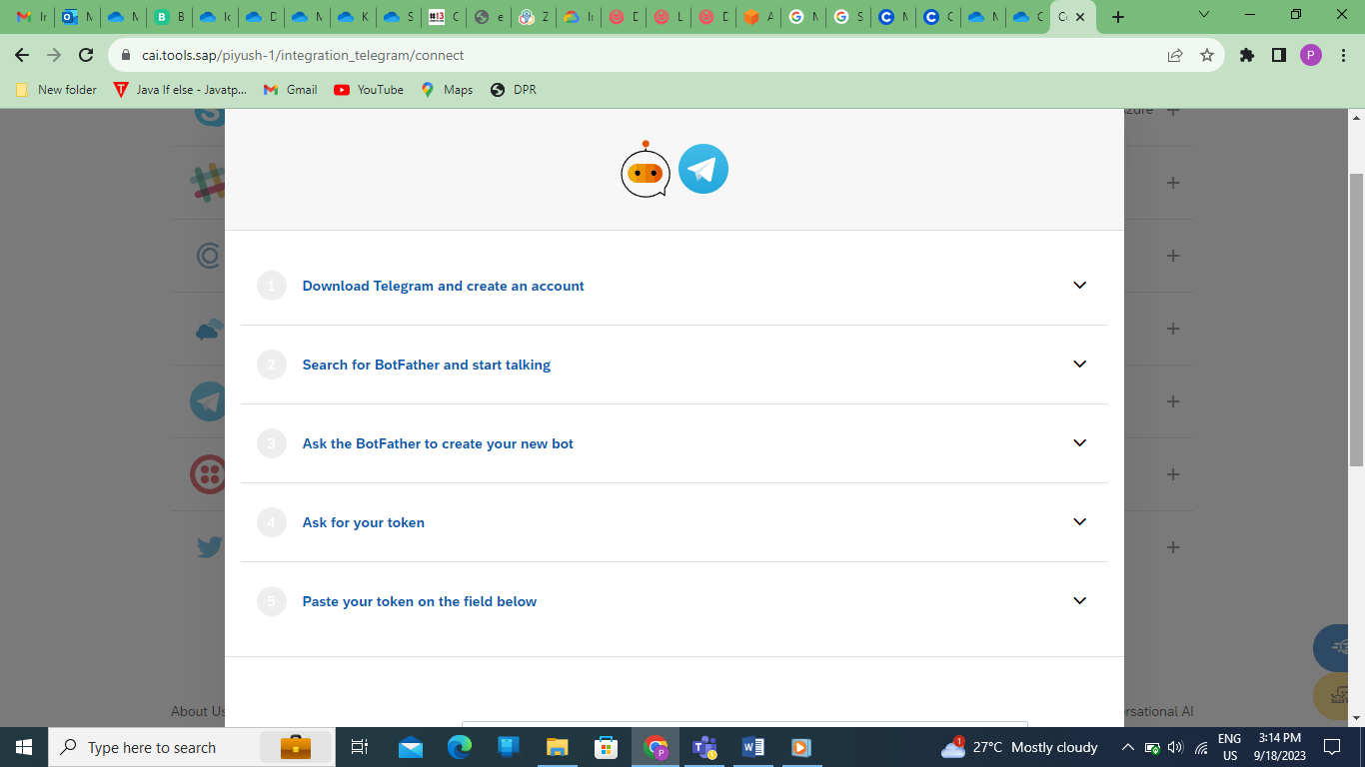

**Create a Telegram Bot:**

1. Start by opening the Telegram app and search for the "BotFather" bot.
2. Send the "/newbot" command to the BotFather.
3. Follow the instructions to set a name and username for your bot.
4. The BotFather will provide you with a unique API token for your bot. Keep this token safe; you'll need it for integration.

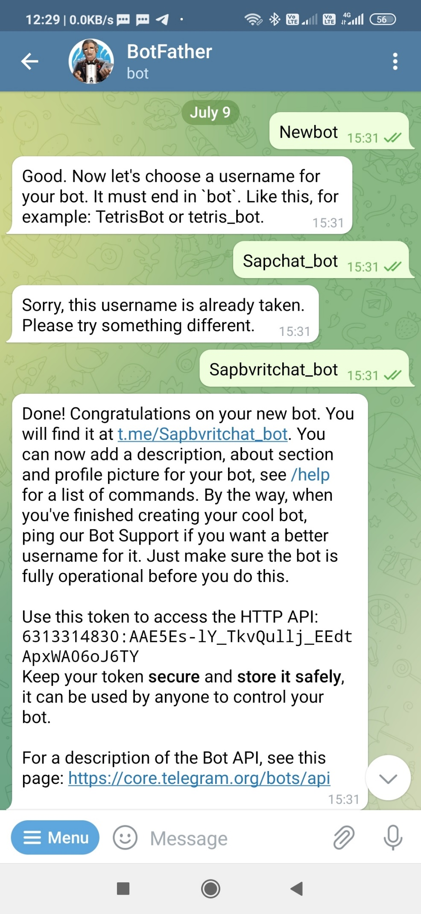

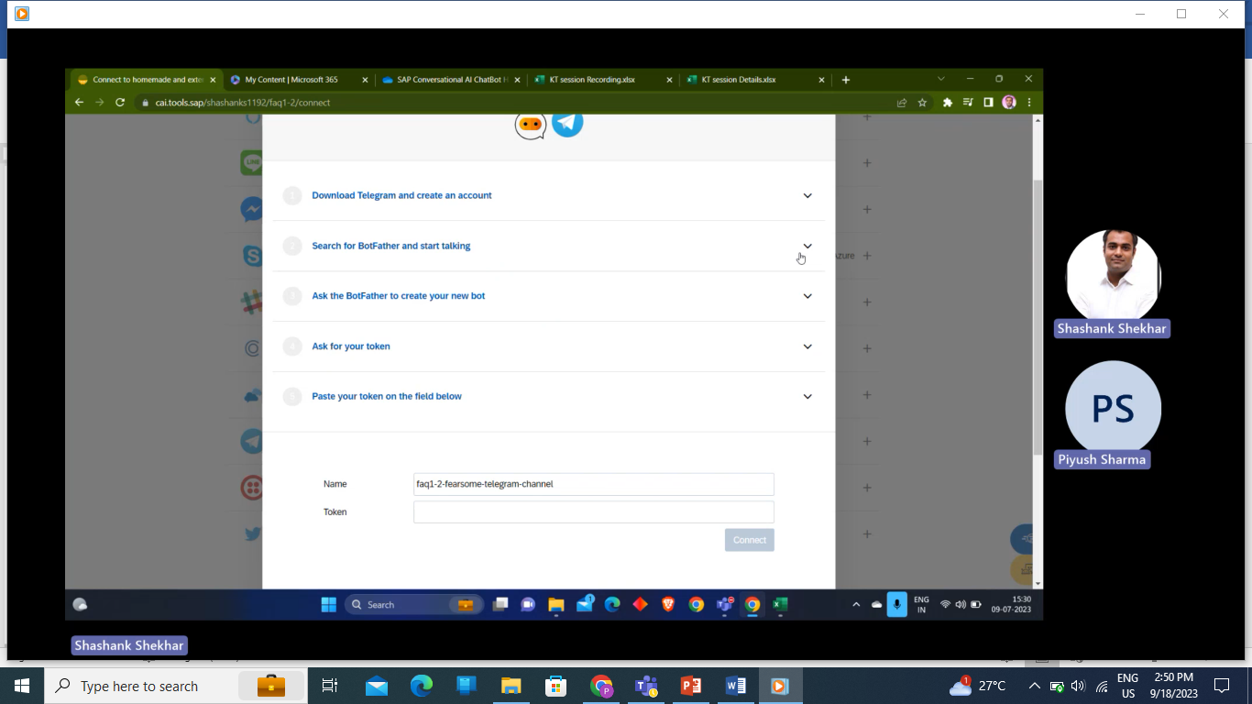

Enter the token to access the HTTP API & Click on Connect

**Use the Telegram Bot API:**

* Integrate your chatbot with the Telegram Bot API using the API token provided by the BotFather. This API allows your bot to send and receive messages, images, and other content with Telegram users.

**Test Your Bot:**

* Test your chatbot by interacting with it on the Telegram app. Make sure it responds correctly to different inputs and commands.

